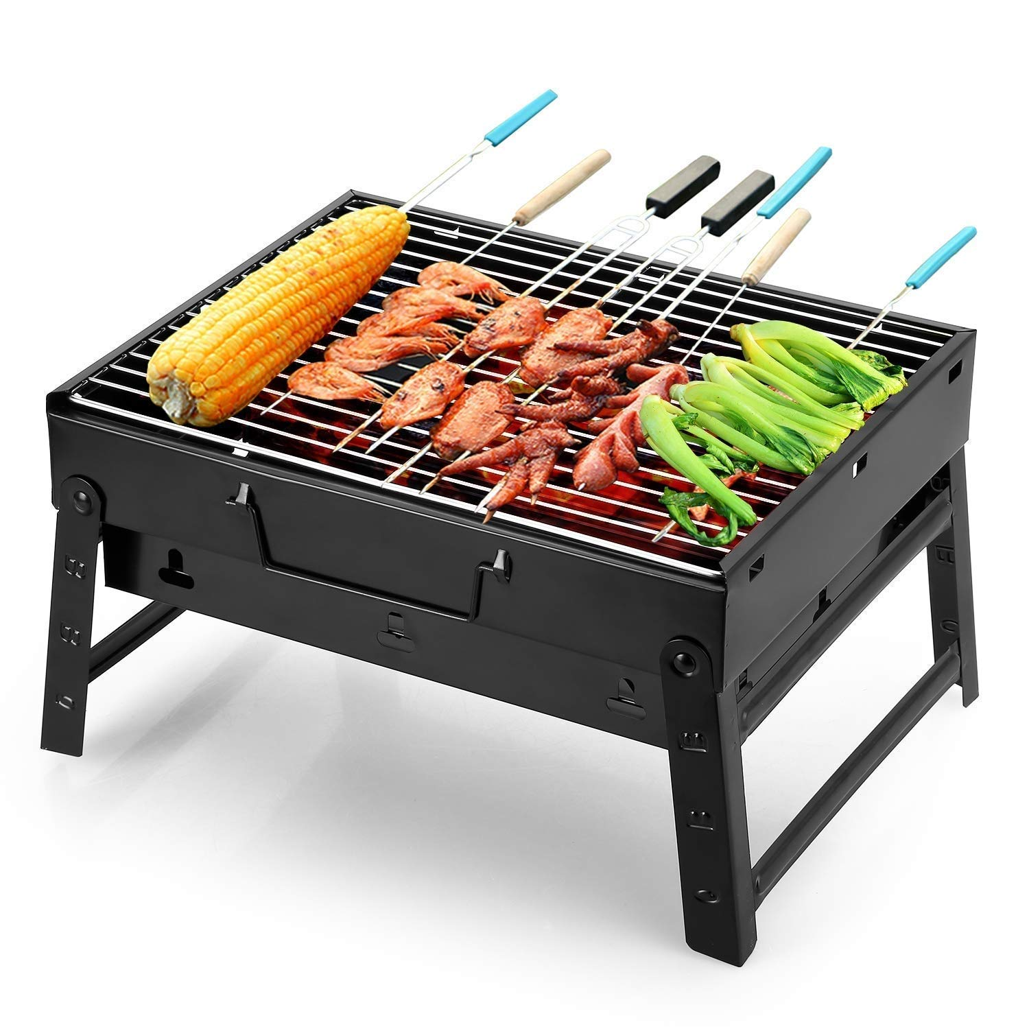
You Are Invited to
ART WORK DAY

Hello Parents, We are having a special day in our campus where you will see and buy beautiful art work pieces made by children.
You can also enjoy BBQ in the garden and some shows made exclusively by kids.
With this we are raising funds for Kindergarten Renovation.
Starts at: 16:00

Task: create flyer
Instructions
- Create a one page flyer for the Fraser Road Kindergarten for their annual fundraiser
- Include the following information on the flyer:
  - Request the public to support their local kindergarten
  - On Saturday 26th March, they are holding an Art Show Day, where they will be selling framed artwork created by the children
  - The Art Show Day is to start at 11am.
  - There will also be cake stalls and a BBQ at lunchtime
  - The fundraiser is to raise funds to have the whole Kindergarten repainted
- Be sure to make it attractive: Include appropriate pictures.
- Spell Check the document and correct any mistakes
- Save this document under your name.

Task: create flyer
Instructions

- Create a one page flyer for the Fraser Road Kindergarten for their annual fundraiser
- Include the following information on the flyer:
  - Request the public to support their local kindergarten
  - On Saturday 26th March, they are holding an Art Show Day, where they will be selling framed artwork created by the children
  - The Art Show Day is to start at 11am.
  - There will also be cake stalls and a BBQ at lunchtime
  - The children have picked out their best work to go on sale
  - The fundraiser is to raise funds to have the whole Kindergarten repainted
  - Include 2 related graphics Include a bulleted list with appropriate pictures
- Be sure to make it attractive
- Spell Check the document and correct any mistakes
- Save this document under your name.

